June 30, 2023
President’s Message
On June 21st, in the evening, we enjoyed a wonderful boat tour of the Port of Long Beach. Veronica Quezada, Port Communication Specialist set up the tour for us. She was also our tour guide. I’ve included a picture of the ASSP Long Beach attendees. We had 16 attendees representing the ASSP Long Beach Chapter. The other attendees were chosen from a lottery. Very different than our Port of Los Angeles boat tour in May. Here’s a picture of some of our group.

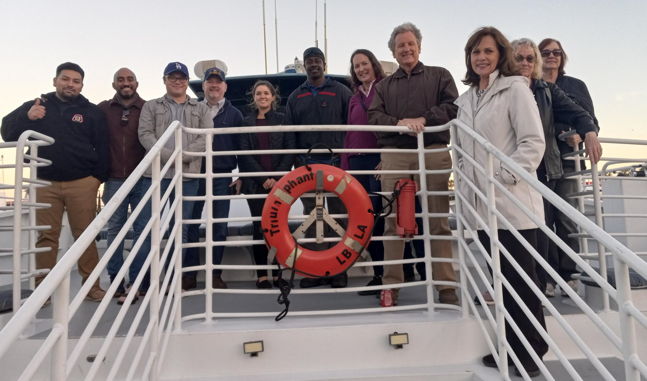

There were several container ships in port during our tour. Here are some amazing pictures of the Port of Long Beach.
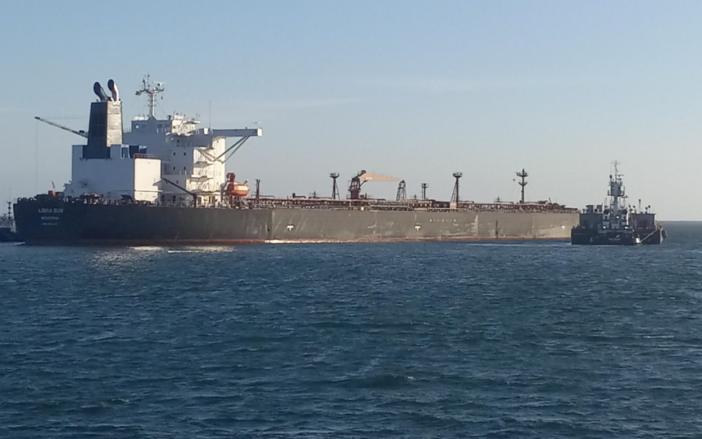

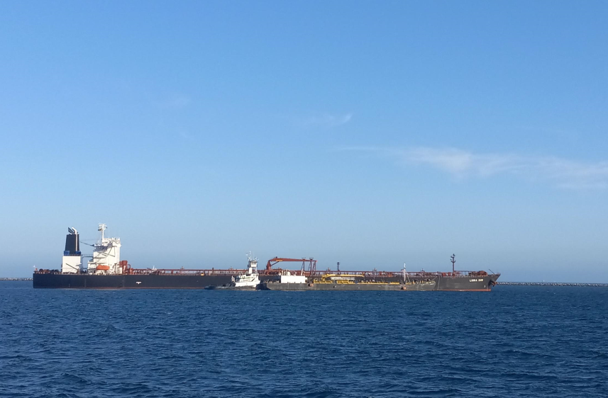

Veronica was a fantastic and knowledgeable tour guide.

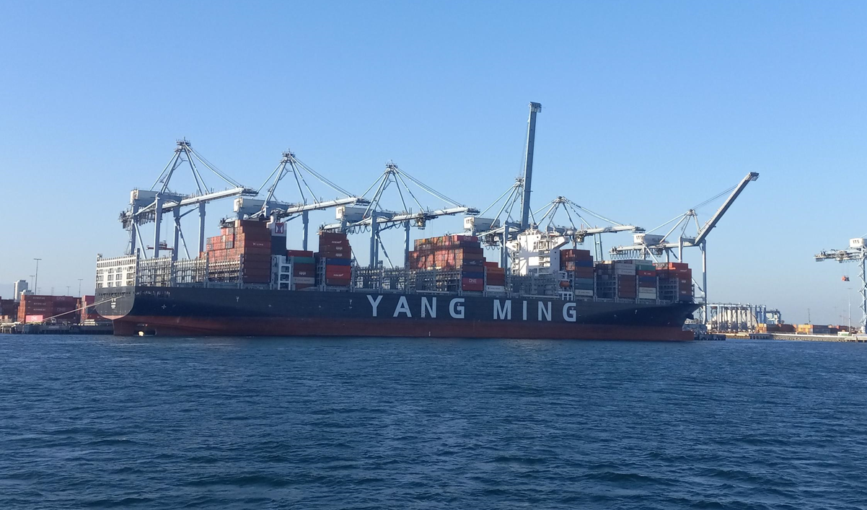
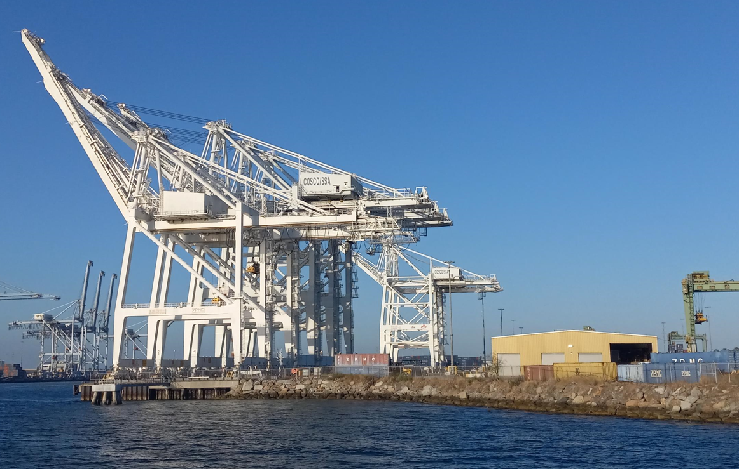
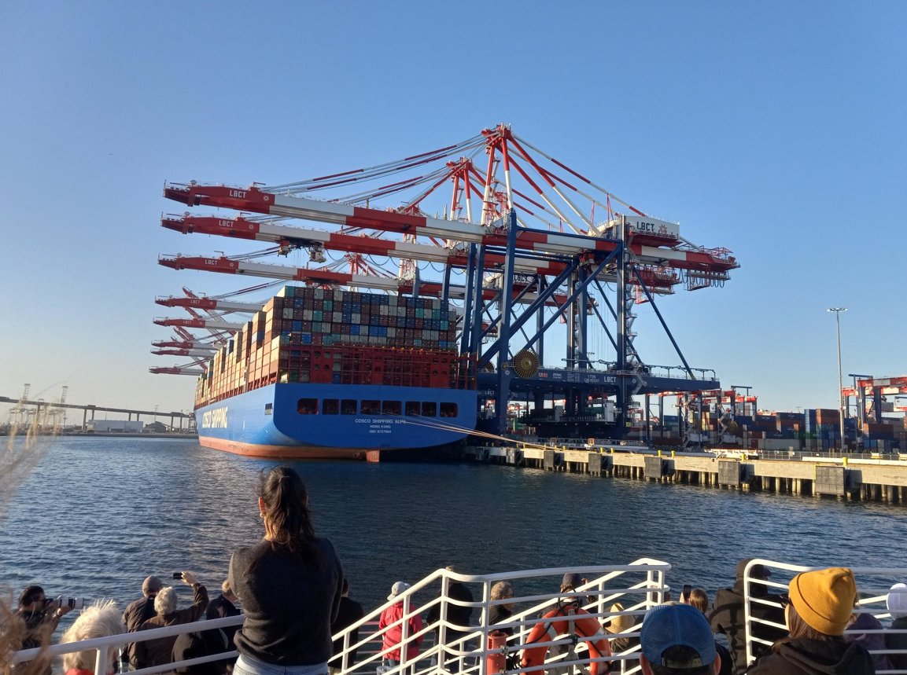
My term as President of the Long Beach Chapter will conclude by the end of today. I’ve really enjoyed working with the Chapter Officers and the accomplishments they’ve achieved this year. We’ve had a variety of speakers, locations and tours this year. Again, I want to thank those that have attended and supported the Long Beach Chapter.
Starting tomorrow, July 1st, the Vice-President, President-elect, Chris Rainwater will be filling the role of President for the Long Beach Chapter. When you have the opportunity, please check our website for updates.
The remainder of this year and next year should be enjoyable with a variety of topics and agendas. Again, I would like to thank all the Chapter Officers, Chapter members and attendees this term that have participated and supported the Chapter.
I’ve had the opportunity to attend the OCAIHA and OCASSP Chapter dinner meeting Wednesday, June 28th. It was held at Pour Vida. The topic was the Cannabis industry. The presentation and discussion was very interesting and the tacos were great.

Have a wonderful 4th of July and be safe!
Karen Townsend

