June 13, 2023

President’s Message

In May, we enjoyed a spectacular boat tour of the Port of Los Angeles. One of our members, John Martinez, Risk Manager of the Port of Los Angeles set up the boat tour for the ASSP Los Angeles Chapter. A picture of ASSP Long Beach attendees can be viewed on our Long Beach Chapter website. There were several other groups representing different organizations on our boat.

There were many container ships in port during our tour. We witnessed the automated process of unloading containers from the vessels. Here are some amazing pictures of the Port of Los Angeles:

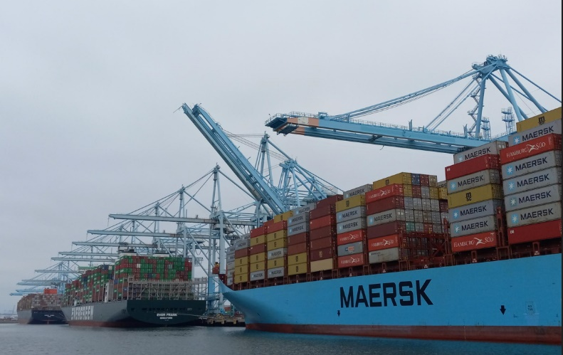

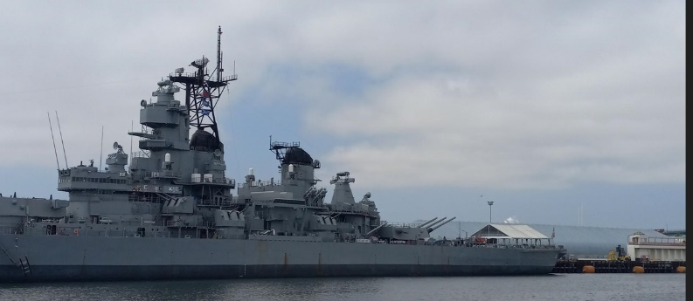

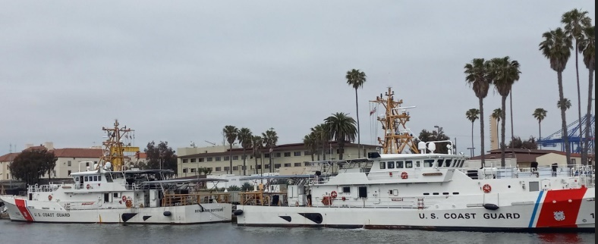

We want to thank John Martinez for setting up the Port of Los Angeles tour. It was a fantastic afternoon.

This month, we have another boat tour scheduled. This time it will be the Port of Long Beach starting from the Aquarium of the Pacific area. It will be held on June 21st at 6:30 PM. Veronica Quezada, Port Communication Specialist set the date. Already we have 20 attendees representing ASSP Long Beach that have RSVP’d. We look forward to our boat tour of the Port of Long Beach. It should be an evening to remember for the Long Beach Chapter.

My term as President of the Long Beach Chapter will be concluded at the end of June. I’ve enjoyed the meetings that have occurred during my term and meeting with those that have attended. I’ve appreciated the speakers that have volunteered to present during our meetings and have enjoyed listening to their presentations. I want to thank those that have attended and supported the Long Beach Chapter.

Starting in July, the Vice-President, President-elect, Chris Rainwater will fill the role of President for the Long Beach Chapter. We have new Board Members to fill open Board positions. The new Board members are posted on our Chapter website and have been updated.

We look forward as a Chapter to the new term, interesting speakers and events that will be scheduled. I would like to thank all of the Board members, Chapter members and attendees this term that have participated and supported the Chapter.

When we have the opportunity, many of us attend other Chapter meetings. The OCAIHA and OCASSP Chapter will host a dinner meeting on June 25th. If you’re able to attend, here’s the link to register: [OCAIHA/OCASSP June Dinner Meeting Tickets, Wed, Jun 28, 2023 at 6:00 PM | Eventbrite](https://urldefense.com/v3/__https:/www.eventbrite.com/e/ocaihaocassp-june-dinner-meeting-tickets-652235312377__;!!P5FZM7ryyeY!Tzq0iMINOTGxpacibLfjgxi_Eq21cQDnTfqrktjLHZh7f13iQKjX_N63zCIkxa2FOR-NO79Rcq4sANl-pvc3mAGLnA$)

Many of the Board members are already planning for the future Southern California Joint Technical Symposium (JTS) scheduled for October 12, 2023. Look for future meeting announcements posted on our website.

There are many opportunities to attend ASSP meetings and activities. When you have the opportunity, please review the up-to-date information on our website.

Have a wonderful June and be safe!

Karen Townsend